**Personal Expense Tracker**

1. **Add an expense:**
2. # List to store all expenses
3. expenses = [   {
4. "Date": "16-07-2025",
5. "Category": "Food",
6. "Amount": 200.0,
7. "Description": "Breakfast at hotel"
8. },
9. {
10. "Date": "16-07-2025",
11. "Category": "Travel",
12. "Amount": 5000.0,
13. "Description": "Flight To Home Town"
14. }
15. ]
16. # Function to add an expense
17. def add_expense():
18. print("\n1. Add an expense:\n")
19. # Input from user for details:-
20. date = input("Enter the date of the expense (YYYY-MM-DD): ")
21. category = input("Enter the category (e.g., Food, Travel): ")
22. amount = float(input("Enter the amount spent: "))
23. description = input("Enter a brief description: ")
24. # Creating a dictionary for the following expense:-
25. expense = {
26. "Date": date,
27. "Category": category,
28. "Amount": amount,
29. "Description": description
30. }
31. # Add dictionary to the list
32. expenses.append(expense)
33. print("\nExpense added successfully!\n")
34. # Call the function:-
35. add_expense()
36. # Show the full list of expenses
37. print("All Expenses:")
38. print(expenses)
39. **OUT Put:-**
40. 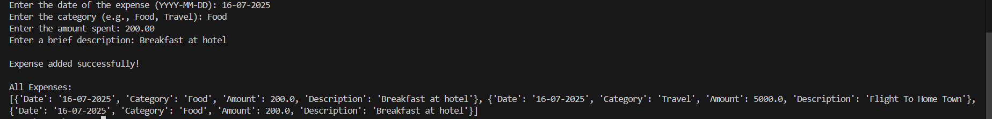

**2. View expenses::-  
  
#List of Function**

**expenses = [**

**{"Date": "16-05-2025", "Category": "Food", "Amount": 200.0, "Description": "Lunch"},**

**{"Date": "16-05-2025", "Category": "Travel", "Amount": 5000.0, "Description": "Flight Ticket"},**

**]**

**#Function Defination**

**def view_expenses():**

**print("List of Expenses:\n")**

**for expense in expenses:**

**# Check if all details are filled**

**if expense["Date"] and expense["Category"] and expense["Amount"] and expense["Description"]:**

**print("Date:", expense["Date"])**

**print("Category:", expense["Category"])**

**print("Amount:", expense["Amount"])**

**print("Description:", expense["Description"])**

**print("-----")**

**else:**

**print("Some details are missing. Skipping this entry.\n")**

**#Call the Function**

**view_expenses()**

**OUTPUT:-  
**

**3. Set and track the budget:**

# List to store expenses

expenses = []

# Function Defination

def set_budget():

    budget = float(input("Enter your monthly budget amount: "))

    return budget

# Function Defination

def add_expense():

    amount = float(input("Enter expense amount: "))

    expenses.append(amount)

# Function Defination

def check_budget(budget):

    total = sum(expenses)

    print("\nTotal expenses :", total)

    if total > budget:

        print("You cross your budget!")

    else:

        left = budget - total

        print("You have", left, "left for the month.")

my_budget = set_budget()

# Add some expenses

add_expense()

add_expense()

# Check budget

check_budget(my_budget)

OUTPUT:-

**4. Save and load expenses:**



import csv

# Empty list to store all expenses

expenses = []

# Load data from CSV file

def load_expenses():

    try:

        with open("expenses.csv", "r") as file:

            reader = csv.reader(file)

            next(reader)

            for row in reader:

                e = {

                    "Date": row[0],

                    "Category": row[1],

                    "Amount": float(row[2]),

                    "Description": row[3]

                }

                expenses.append(e)

        print("Expenses loaded.")

    except FileNotFoundError:

        print("No file found. Starting with an empty list.")

ef save_expenses():

    with open("expenses.csv", "w", newline="") as file:

        writer = csv.writer(file)

        writer.writerow(["Date", "Category", "Amount", "Description"])

        for e in expenses:

            writer.writerow([e["Date"], e["Category"], e["Amount"], e["Description"]])

    print("Expenses saved.")

# 1.Add a new expense using user input

def add_expense():

    print("\nAdd New Expense:")

    date = input("Enter date (YYYY-MM-DD): ")

    category = input("Enter category: ")

    amount = float(input("Enter amount: "))

    description = input("Enter description: ")

e = {

        "Date": date,

        "Category": category,

        "Amount": amount,

        "Description": description

    }

    expenses.append(e)

    print("Expense added.")

#2. Show all saved expenses

def view_expenses():

    print("\nAll Expenses:")

    for e in expenses:

        print(f"{e['Date']} | {e['Category']} | {e['Amount']} | {e['Description']}")

    print()

#3. Program starts here

load_expenses()

while True:

    print("\nWhat do you want to do?")

    print("1. Add Expense")

    print("2. View Expenses")

    print("3. Save and Exit")

    choice = input("Enter your choice (1-2-3): ")

    if choice == "1":

        add_expense()

    elif choice == "2":

        view_expenses()

    elif choice == "3":

        save_expenses()

        print("Goodbye!")

        break

    else:

        print("Invalid choice. Please enter 1, 2, or 3.")

OUTPUT:-

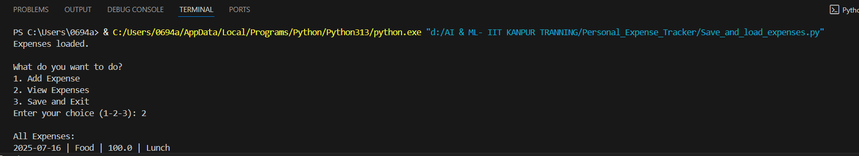

**5. Create an interactive menu:**

# List of data

dates = []

categories = []

amounts = []

descriptions = []

# Function Difination

def add_expense():

    d = input("Enter date: ")

    c = input("Enter category: ")

    a = input("Enter amount: ")

    desc = input("Enter description: ")

    dates.append(d)

    categories.append(c)

    amounts.append(a)

    descriptions.append(desc)

    print("Expense added!\n")

# Function Defination to view expenses

def view_expenses():

    if len(dates) == 0:

        print("No expenses added.\n")

    else:

        for i in range(len(dates)):

            print("Date:", dates[i])

            print("Category:", categories[i])

            print("Amount:", amounts[i])

            print("Description:", descriptions[i])

            print("----")

        print()

# Function defination to track budget

def track_budget():

    total = 0

    for amt in amounts:

        total += float(amt)

    print("Total Spent:", total, "\n")

# Menu List

def menu():

    print("1. Add expense")

    print("2. View expenses")

    print("3. Track budget")

    print("4. Exit")

# Condition

while True:

    menu()

    choice = input("Enter your choice: ")

    if choice == "1":

        add_expense()

    elif choice == "2":

        view_expenses()

    elif choice == "3":

        track_budget()

    elif choice == "4":

        print("Thank you! Exiting.")

        break

    else:

        print("Wrong choice. Try again.\n")

OutPut:-  
